Head fixation post
The main requirement for the head fixation system is related with intrinsic nature of the rotation of the animal in the environment. The observation of neurons through the implanted cranial window on the head of the rodent while that one rotates require an independent system to align the axis of the motor rotation with the microscope field of view (Figure 1).
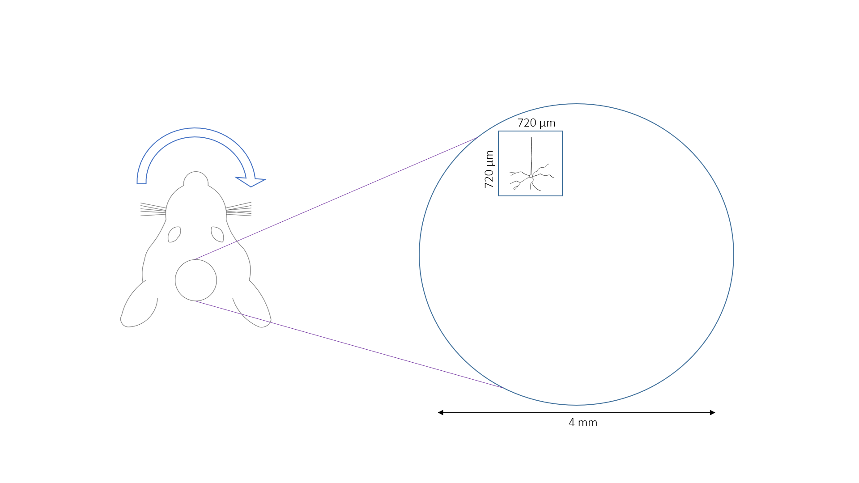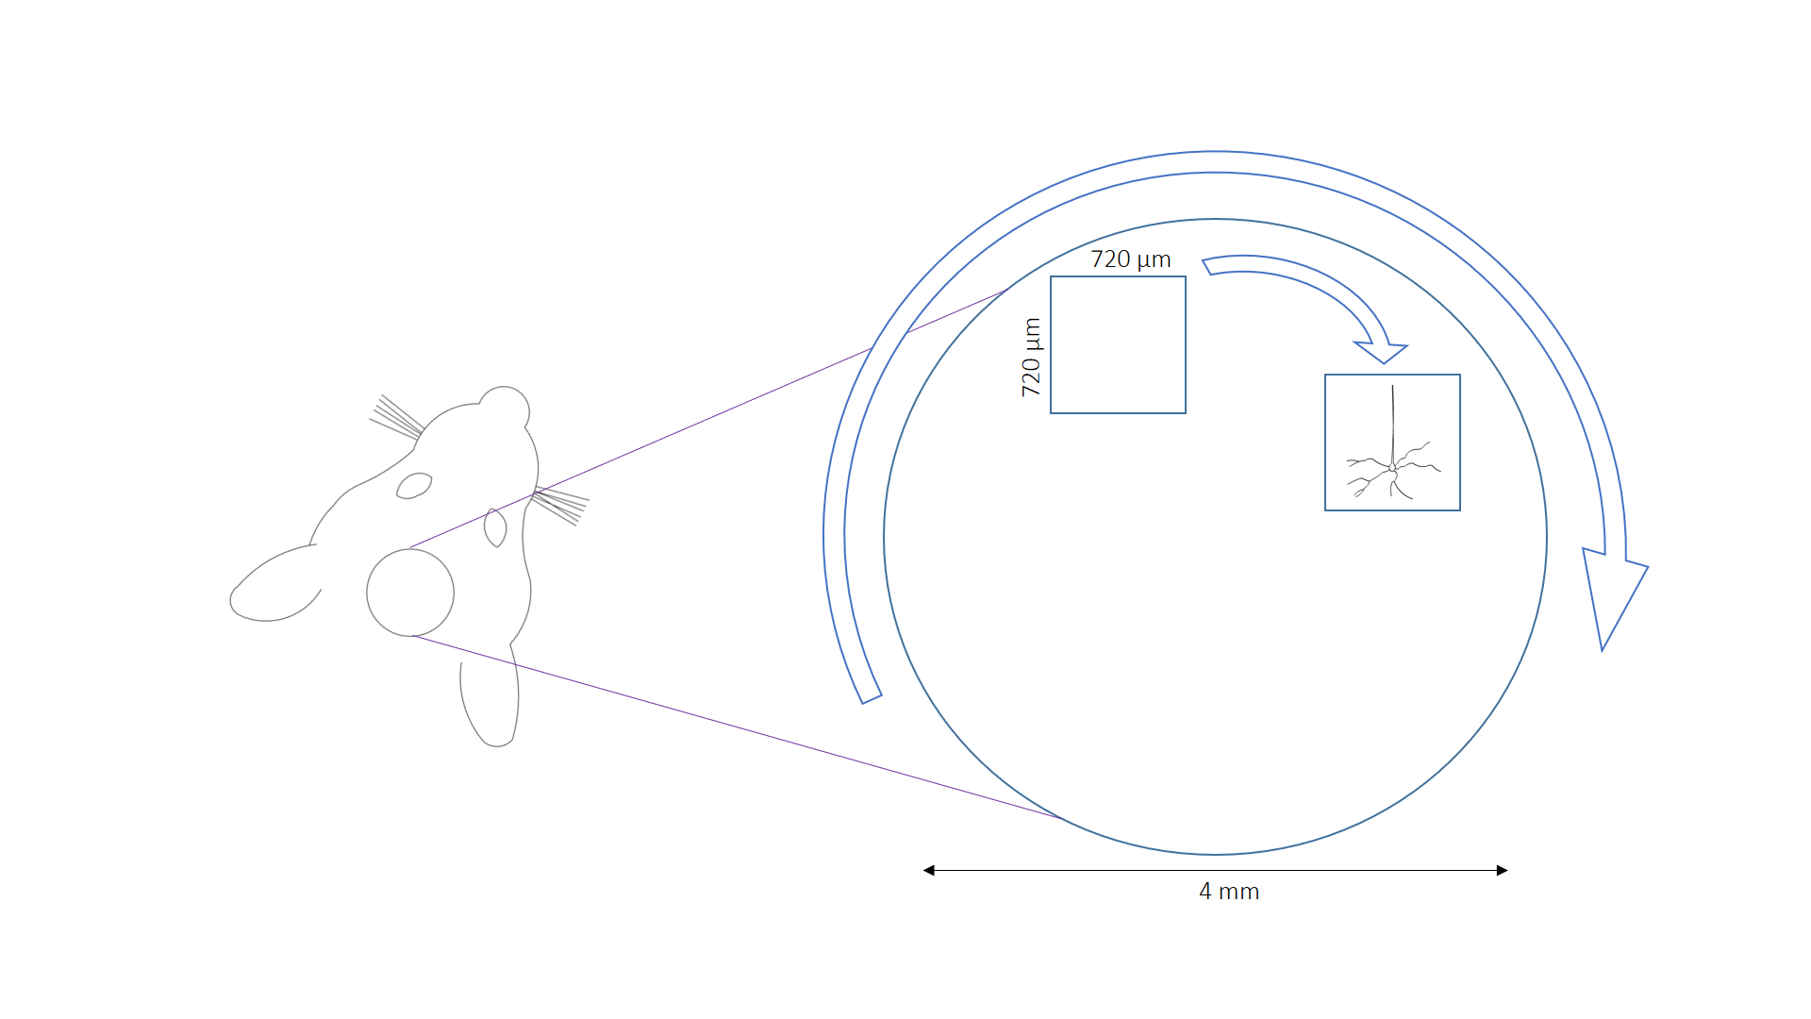
Figure 1: Displacement of the cells due to the animal’s head rotation.
For these reason a three degrees of freedom head fixation post has been designed to get the displacements on the plane (Figure 2) and the z displacement to adjust the height depending on the animal’s size.
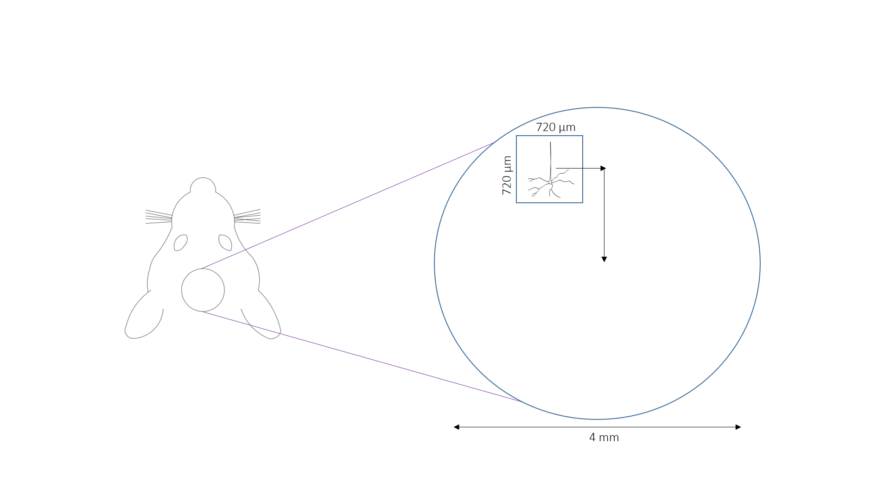
Figure 2: Readjustment of this center of rotation.
This head post is based on the assembly of 3 Thorlabs® translational stage MT1\M to get the three translational movements with reliability. The main goals of this design are: (1) Adjust the height from mouse to mouse, (2) Adjust the center of the microscope field of view with the center of rotation and (3) reliability and repeatability experiment after experiment. Also the MT405 side mounted actuator adapter. The resolution of the system is 10 microns, the smallest measure of the micrometers and the range of each micrometer is 13 mm.
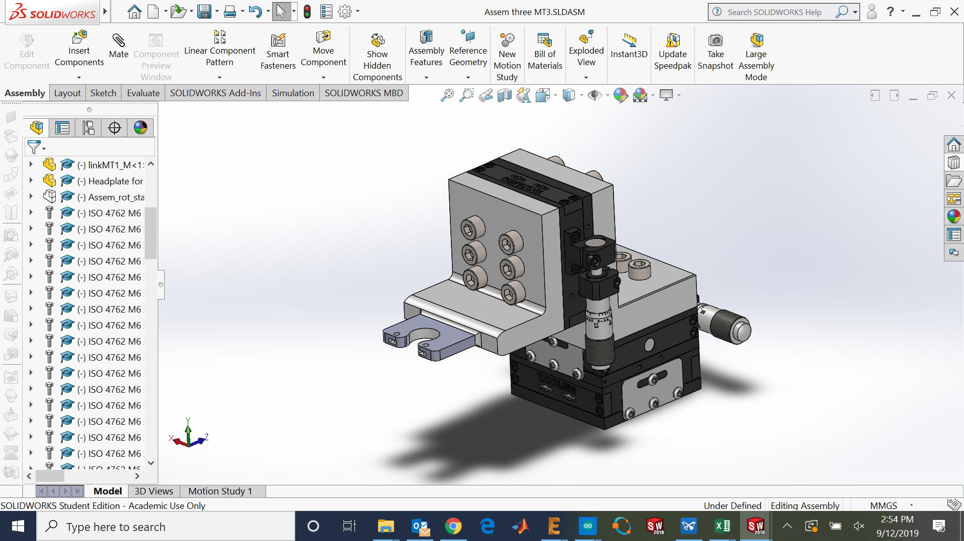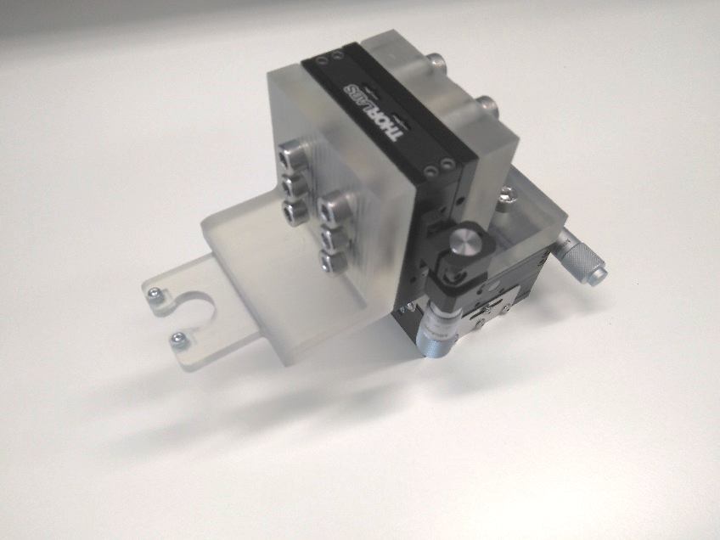
Figure 3: Virtual assembly of the head post designed using Solidworks ® software (left) and real assembly (right).
The materials needed for the assembly are: the 2 3D printable parts, the three MT1\M translational stages, three MT405 side mounted actuator adapter, two M2.5 Nuts, two hexagonal M2.5 screws, fifteen M6 screws two of them optional and two Bollhoff M6 threaded inserts (also optional).
Table 1: Bill of materials.
Part name | Manufacturer | Units | Reference
Link | 3D printed part | 1 | Link.STL
Head plate | 3D printed part | 1 | Head_plate.STL
MT1/M translational stage | Thorlabs | 3 | MT1/M
MT405 side mounted actuator adapter | Thorlabs | 3 | MT405
M6 hex bold screws 16mm length | RS components | 15 (2 optional) | 281-144
M2.5 hex bold screws | RS components | 2 | 483-8124
M2.5 nuts | RS components | 2 | 560-287
M6 threaded inserts | RS components | 2 (optional) | 664-7359

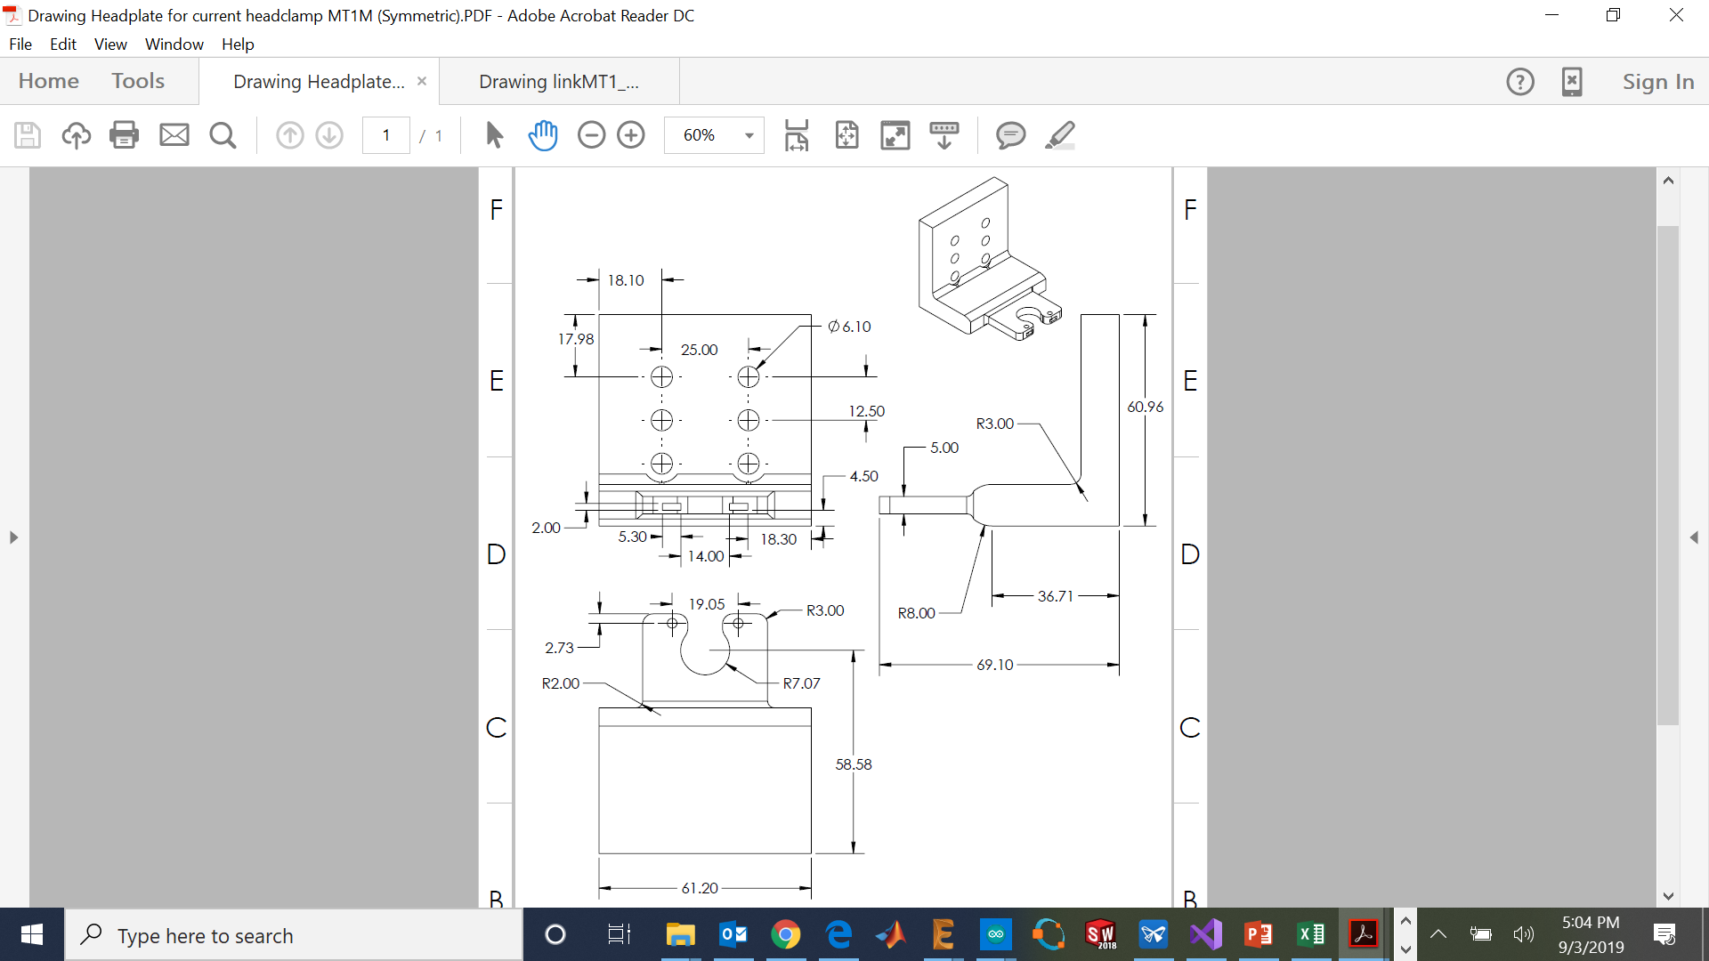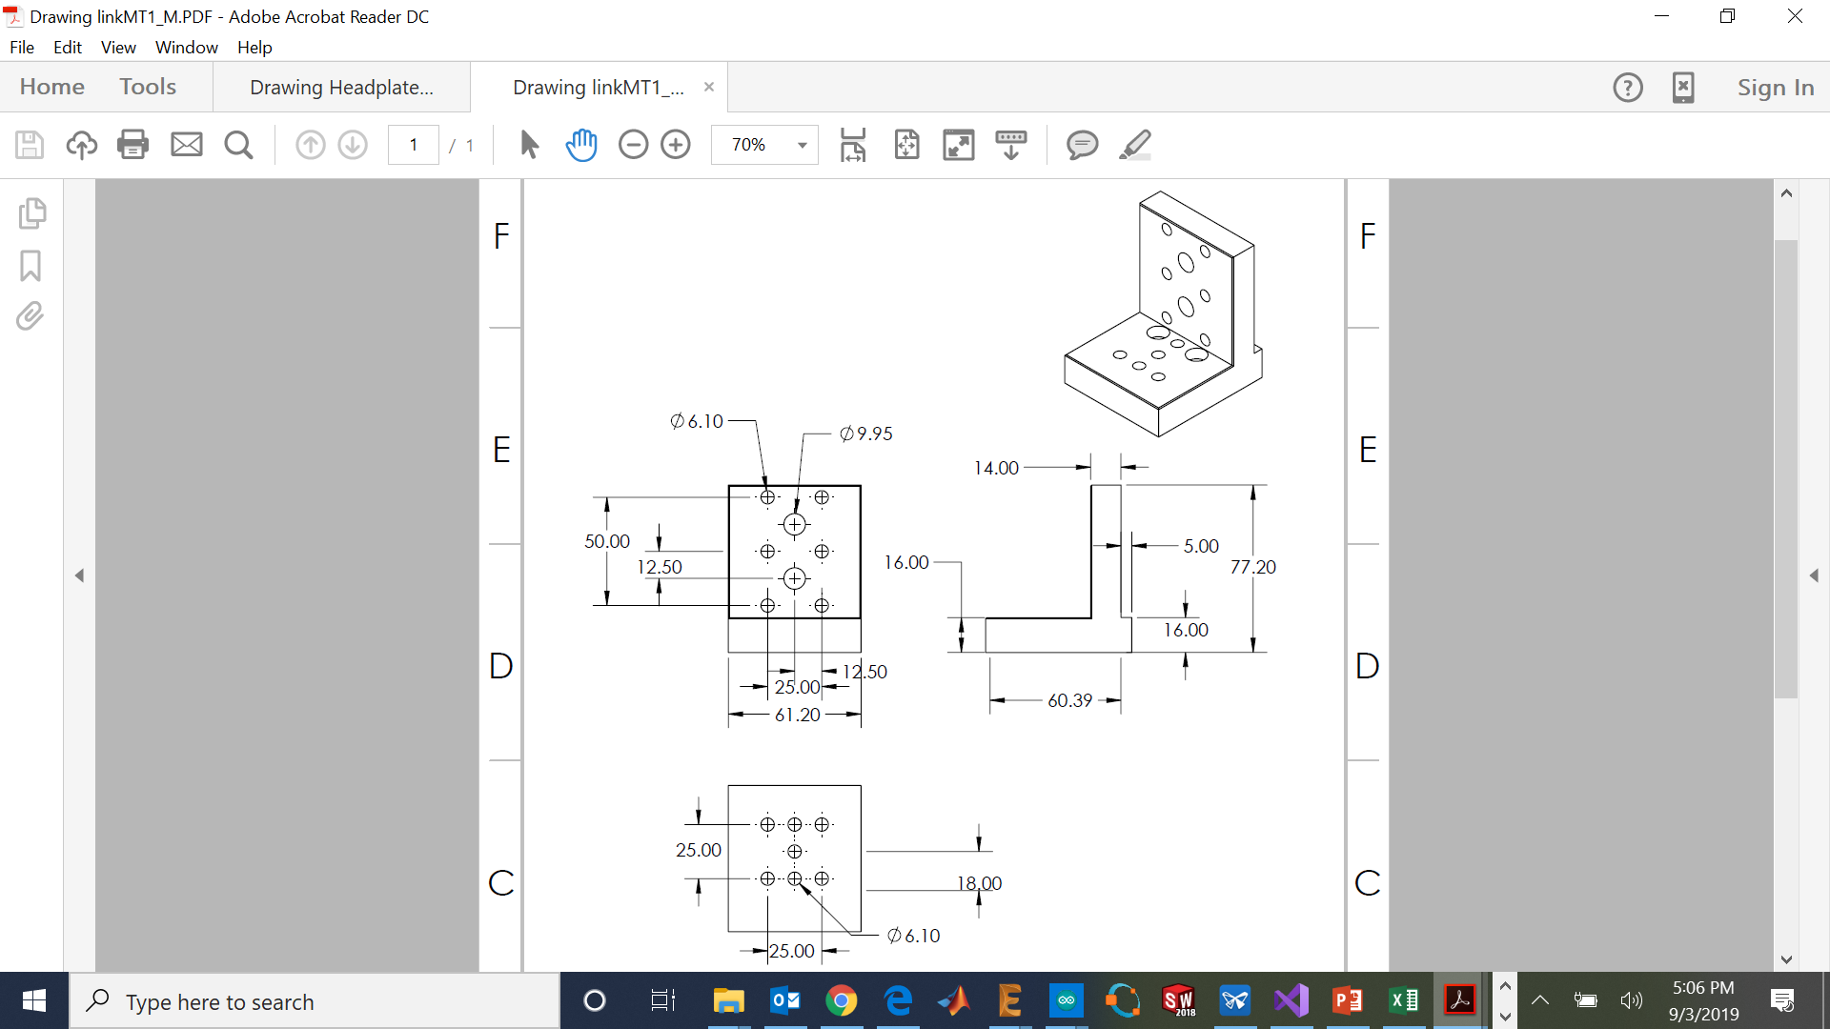
Figure 4: Drawings of the two 3D printable parts head plate 1:1 scale (left) and link 1:2 scale (right).
The 3D printed parts have been printed using a Form2 SLS 3D printer from Formlabs ® using the standard features with Clear resin type.
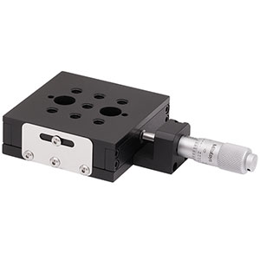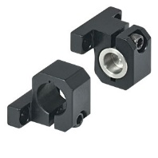
Figure 5: Thorlabs components needed: MT1\M translational stage (left) and MT405 side mounted actuator adapter (right).
Assembly instructions
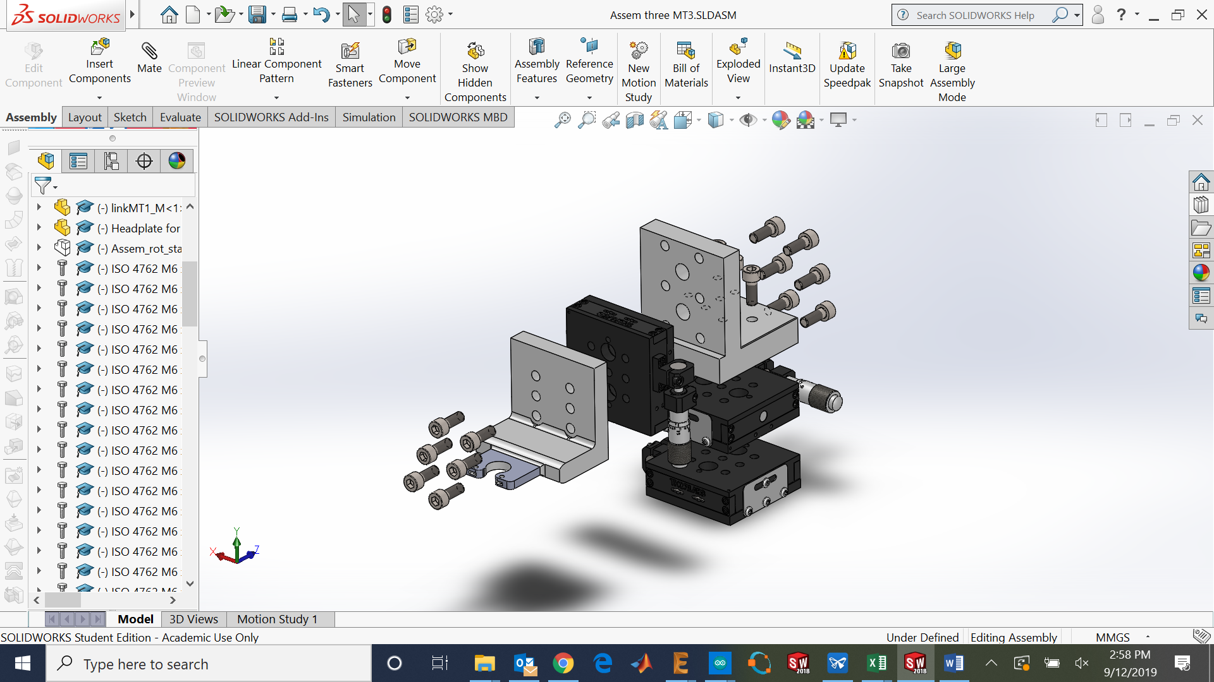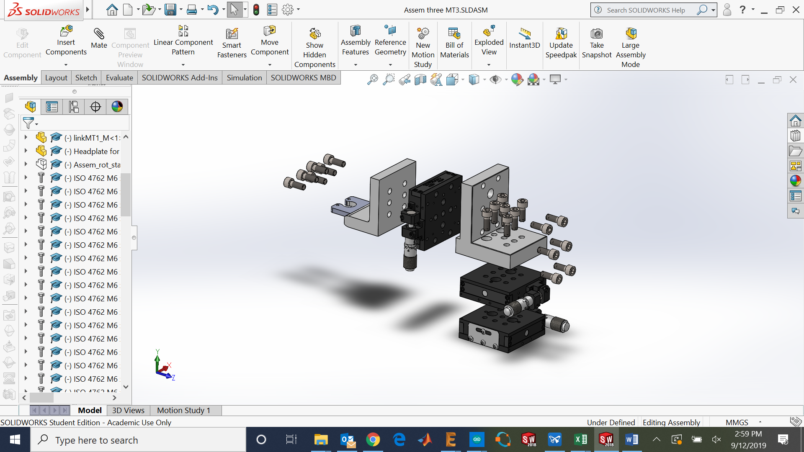
Figure 6: Exploded view of the assembly.
- Remove the support material of both parts.
- Insert the M2.5 nuts on the square holes making the thread hole coincident with the plastic hole in the Head plate part.
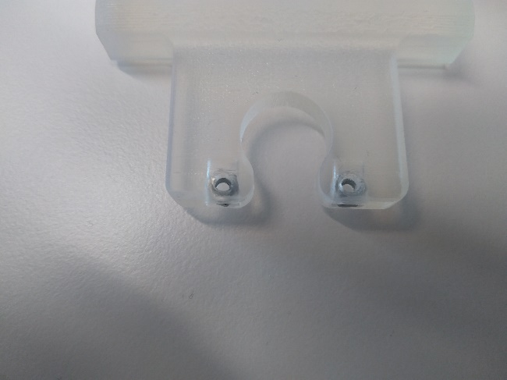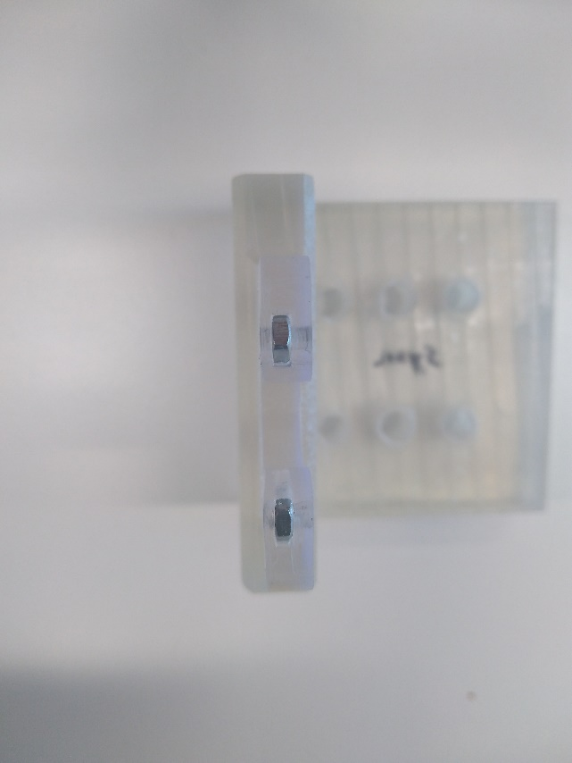
Figure 7: M 2.5 nuts inserted before the curing process.
- Use a M6 drill to redo all the M6 holes for both parts.
- Cure the parts for 20 minutes at with UV light and 60°C.
- Remove the micrometer mount from the MT1\M translational stages.
- Screw the MT405 side mounts to the linear stages with the corresponding micrometers.
- Screw two of the MT1\M linear stages with a phase of 90 degrees.
- Screw the link base on the top of the two MT1\M (seven M6 screws).
- Screw the other MT1\M in the vertical position coincident with the six M6 holes.

Roll rotary stage
During imaging experiments sometimes is needed to change the orientation of the normal vector of the surface of the brain to get better images. For this reason, a roll rotation stage has been designed to add one more degree of freedom and get this feature.
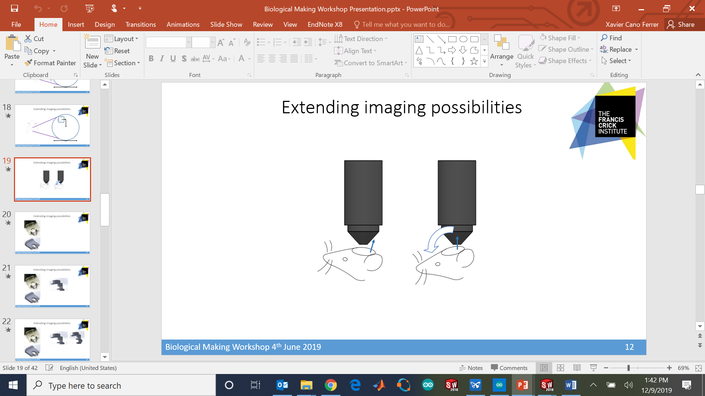
Figure 8: Change in the orientation of the surface’s normal vector.
The mechanical system is based on a worm gear mechanism in order to get precision and high torque on the rotation and movement only in the axis where the tool is applying torque. This system can be optionally added instead of the head plate described previously. In this head plate the two M2.5 nuts are displaced 3 mm forward from the previous position.

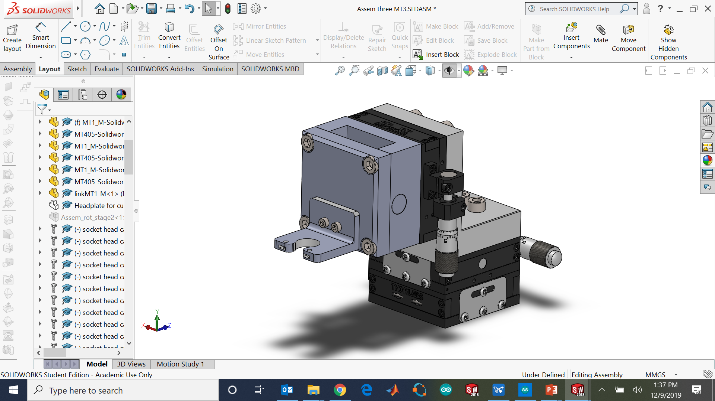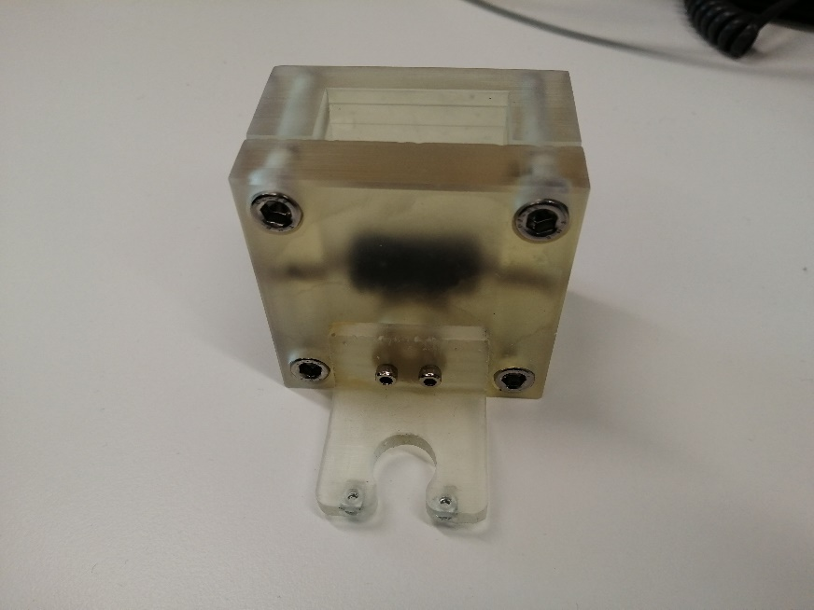
Figure 9: Roll rotary stage assembled with the head post.
Table 2: Bill of materials.
Part name | Manufacturer | Units | Reference
Rotary head plate | 3D printed part | 1 | Rotary head plate.STL
Mechanical system cover | 3D printed part | 1 | Mechanical system cover.STL
Mechanical system base | 3D printed part | 1 | Mechanical system base.STL
Worm gear | RS Components | 1 | 521-8559
Spur gear | RS Components | 1 | 521-6834
M3 screws | RS Components | 2 | 908-7497
M5 screws (30mm) | RS Components | 1 | 124-7222
M6 screws (Hexagonal bolt) | RS Components | 4 | 483-8348
M6 screw | RS Components | 4 | 232-8467
M6 screw (long) | RS Components | 1 | 124-7227
M6 nut | RS Components | 1 | 524-326
M2.5 nuts | RS components | 2 | 560-287

For this system is necessary to make two additional holes on the brass gear with an M3 thread coincident with the two holes of the head plate, at 5 mm from the center of the 5 mm concentric hole (Figure 10).
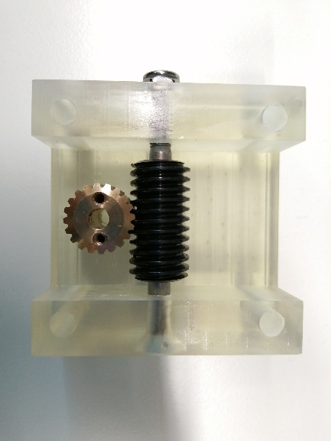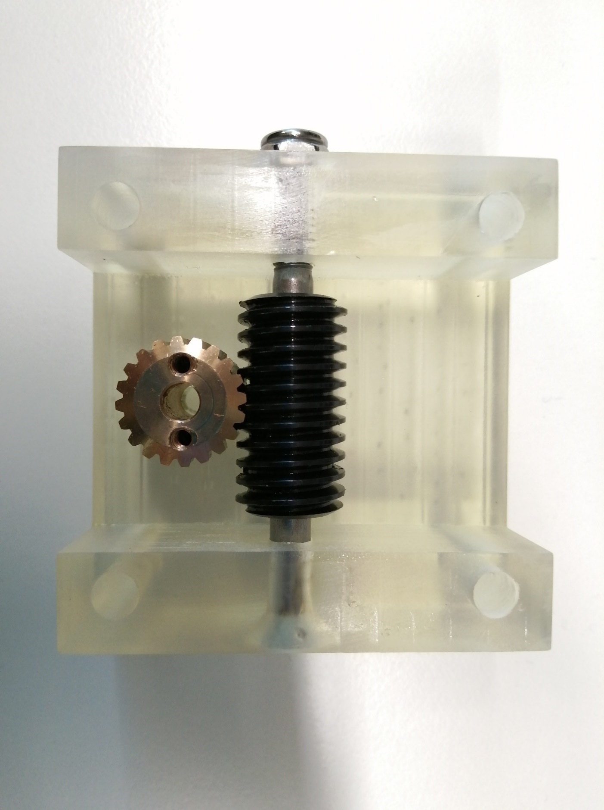
Figure 10: Additional M3 holes on the spur gear.
Assembly instructions
- Insert the M6 threaded inserts on the back of the case.
- Insert the M2.5 nuts on the head plate (like in the previous instructions)
- Assemble the case with the Thorlabs® linear stage.
- Place the brass spur gear in its position with the M5 screw on its axis.
- Insert the M6 long screw with the worm gear inside and tread it on the blocking nut.
- Attach the cover with the four M6 screws.
- And place the head plate on the hole for it and insert the M3 screws on the brass spur gear additional holes.
- Cure all the parts separately at 60 °C on the Form Cure for 20 minutes.

